Unit 7 test
Vocabulary
Vocabulary
1 Look, read and complete.
brush brush do get get go go have
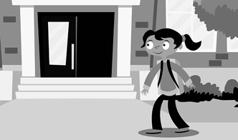 | 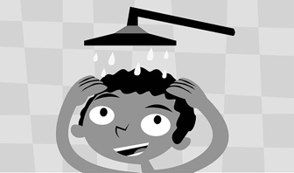 |  | 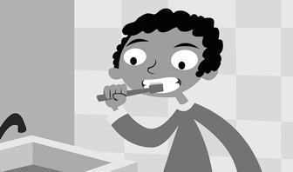
1  to school | 2  a shower | 3  my hair | 4  my teeth
 | 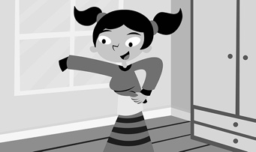 | 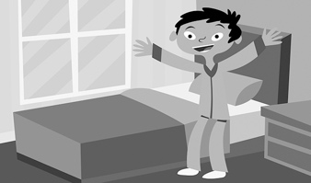 | 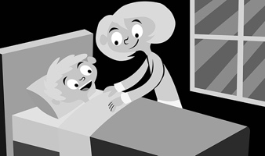
5  my homework | 6  dressed | 7  up | 8  to bed
/ 8
2 Look, read and circle.
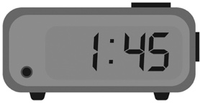 | 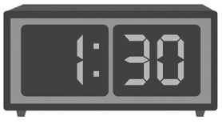 | 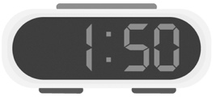 |  | 1 one o’clock / one forty-five  2 one thirty / one twenty  3 one fifteen / one fifty  4 one o’clock / one thirty  5 one twenty / one forty-five  6 one thirty / one fifteen
1 | 2 | 3
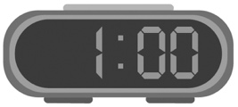 | 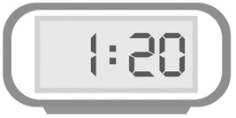 | 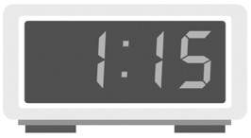
4 | 5 | 6
/ 6

Grammar
3 Look, read and circle.
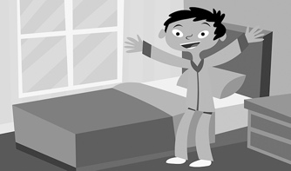 |  | 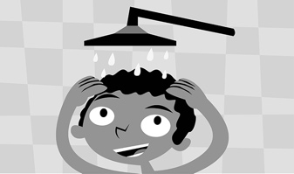
1 What do you do in the morning?  I go to bed / get up. | 2 What do you do in the afternoon?  I have a shower  / do my homework. | 3 What do you do in the evening?  I have / don’t have  a shower.
 | 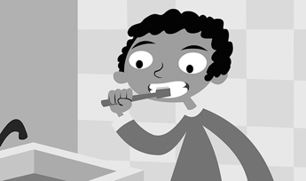
4 What do you do on Monday?  I don’t brush / brush  my hair. | 5 What do you do on Sunday?  I don’t go / go to school.
/ 5
4 Look, read and tick ().
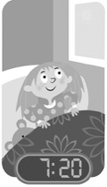 | 1 What time does she get up?  A ☐ She doesn’t get up at 7.20.  B ☐ She gets up at 7.20.
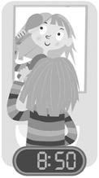 | 2 What time does she brush her hair?  A ☐ She brushes her hair at 8.50.  B ☐ She doesn’t brush her hair at 8.50.
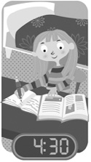 | 3 What time does she do her homework?  A ☐ She doesn’t do her homework at 5.30.  B ☐ She does her homework at 5.30.
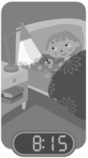 | 4 What time does she go to bed?  A ☐ She goes to bed at 9.15.  B ☐ She doesn’t go to bed at 9.15.
/ 4
Reading
5 Read. Complete the sentences. Write one word.
Hi, I’m Kim! This is my family routine.
I get up at seven o’clock in the morning. I get dressed and I have breakfast. I go to school at eight o’clock. I go to school in the morning and the afternoon. I have dinner with Mum in the evening. We eat lots of noodles! Mum gets up at six thirty and she brushes her teeth. She works at home
in the morning. She goes to work at one o’clock. She’s a bus driver.
In the evening, she has a shower. She goes to bed at ten o’clock.
1 Kim gets up at o’clock.
2 She has in the morning.
3 Kim’s mum is a driver.
4 Kim’s mum goes to at ten o’clock.
/ 4
Writing
6 Write.
1 My dad a shower in the morning.
2 I my homework at 4.00.
3 She dressed at 7.30.
4 She has breakfast and her teeth.
/ 4

Listening
7  7 Listen and write the letter.
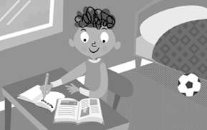 | 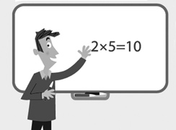 |  |  | 1 10.50  2 6.20  3 8.15  4 9.00  5 4.30
A | B | C
 | 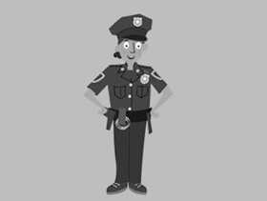
D | E
/ 5
Speaking
8 Look, read and answer.
 | Ava | Leo
 | 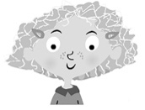 | 
7.30 | 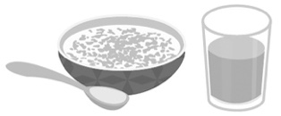 | 
8.00 | 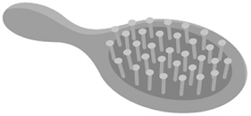 | 
1 When does Ava have breakfast?
2 When does Leo brush his teeth?
3 What do you do in the morning?
4 What do you do on Saturday?
/ 4
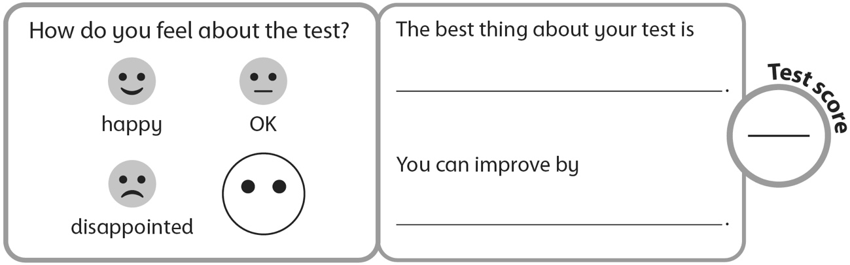
40

